COURSE CCPS 510
DATABASE SYSTEMS (DBMS) I
ASSIGMENT-I (Version1)

INSTRUCTOR: | Ersan Cam
INSTRUCTOR E-MAIL: | ersan.cam@torontomu.ca

Please place all your answers and screen shots of your results into this document. Once you finish working on this file, please email me.

This Assignment has different parts each represent different Labs (Ideal time to solve these are in dedicated Lab times of the course)

Lab Section- A:

Task1)
Suppose you are working within the framework of the conceptual model in Figure 1 below.

Figure 1 The Conceptual Model Car Maintenance Services
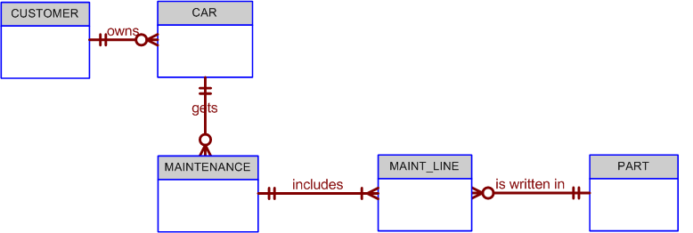

Given the conceptual model in Figure 1:

  - Write the business rules that are reflected in it.

Even a simple ERD such as the one shown in Figure Q4.5 is based on many business rules. Make sure that each business rule is written on a separate line and that all of its details are spelled out. In this case, the business rules are derived from the ERD in a “reverse-engineering” procedure designed to document the database design. In a real world database design situation, the ERD is generated on the basis of business rules that are written before the first entity box is drawn. (Remember that the business rules are derived from a carefully and precisely written description of operations.)

Here are business rules:
1.
2.
3.
4.
5.
6.

Task 2)
Below questions is based on the ERD in Figure 2.
FIGURE 2 - The ERD of
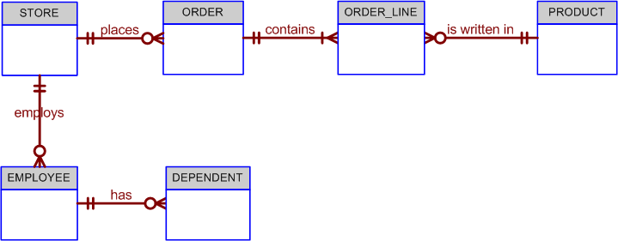

2-a)
Fill Cardinalities. I have left 2 of them on the diagram for you as hint. You can fill rest of 8
The Cardinalities
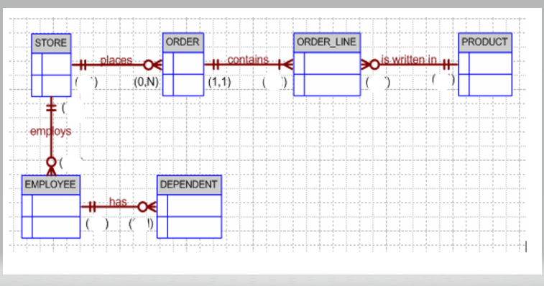

P.S: You can print and write on the paper and take picture and paste here or take this above picture as screen shot and edit on it or use draw.io free cloud tool to complete ERD diagrams.

2-b ) Write at least 6 Business Rules by analyzing ERD diagram above

Normalization

3)
Given the structure shown in Table P3.1, write the relational schema and draw its dependency diagram. Label all transitive and/or partial dependencies.

The dependency diagram is shown in Figure P3.1a. Note that the order of the attributes has been changed to make the transitive dependencies easier to mark. (In any case, the order in which the attributes are written into a relational database table is immaterial.) The relational schema is written below Figure P6.6a.

Figure P3.1a The Dependency Diagram for Problem 3
The relational schema is written as:

EMPLOYEE(EMP_CODE, EMP_LNAME, EMP_EDUCATION, JOB_CLASS,
EMP_DEPENDENTS,DEPT_CODE, DEPT_NAME, DEPT_MANAGER,
EMP_TITLE, EMP_DOB, EMP_HIRE_DATE, EMP_TRAINING,
EMP_BASE_SALARY, EMP_COMMISSION_RATE)

b. If we draw the dependency diagrams that are in 3NF.

Dependency diagrams have no way to indicate multi-valued attributes, nor do they provide the means through which such attributes can be handled. Therefore, the solution to this problem requires a basic knowledge of modeling concepts, once again indicating that normalization and design are part of the same process. Given the sample data shown in Problem 6, EDUCATION, DEPENDENT and QUALIFICATION are multi-valued attributes whose values are stored as strings. We have created the appropriate entities to avoid the use of multi-valued attributes. (See Figure P6.6b.)

Figure P3.1b The Dependency Diagrams for Problem in b

The relational schemas are written as:
Please mark Primary Key for each table with Bold and Underline (Sample hint is given to you for DEPARTMENT table

EMPLOYEE(EMP_CODE, EMP_LNAME, DEPT_CODE, JOB_CLASS, EMP_DOB,
EMP_HIREDATE)

DEPENDENT(EMP_CODE, DEP_NUM, DEP_FNAME, DEP_TYPE)

DEPARTMENT(DEPT_CODE, DEPT_NAME, EMP_CODE)

JOB(JOB_CLASS, JOB_TITLE, JOB_BASE_SALARY)

EDUCATION(EDUC_CODE, EDUC_DESCRIPTION)

QUALIFICATION(EMP_CODE, EDUC_CODE, QUAL_DATE_EARNED)

c. Draw the relational diagram (ERD with Chen or Crows foot).

Draw ERD diagram with www.draw.io or visio or draft on paper with pencil and take picture and paste here.

This following section (Lab B) is for Physical Database Design practices to build database tables and add constraints to apply business rules by using DDL (Data Definition Language ) of SQL.
Lab Section- B: DDL (Data Definition Commands) to create physical Database
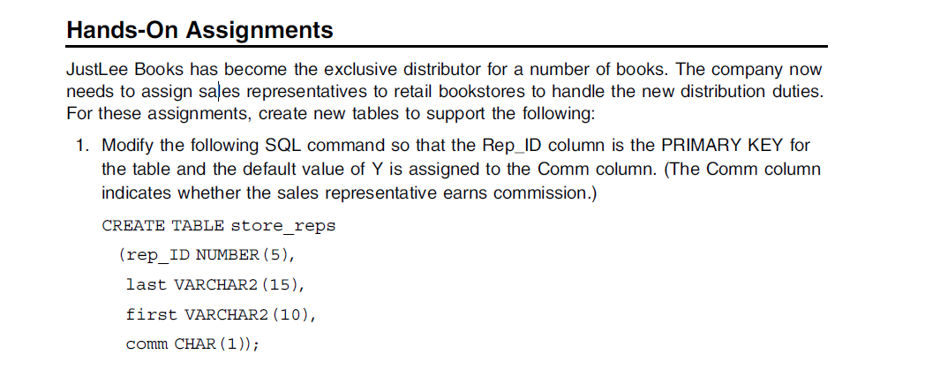
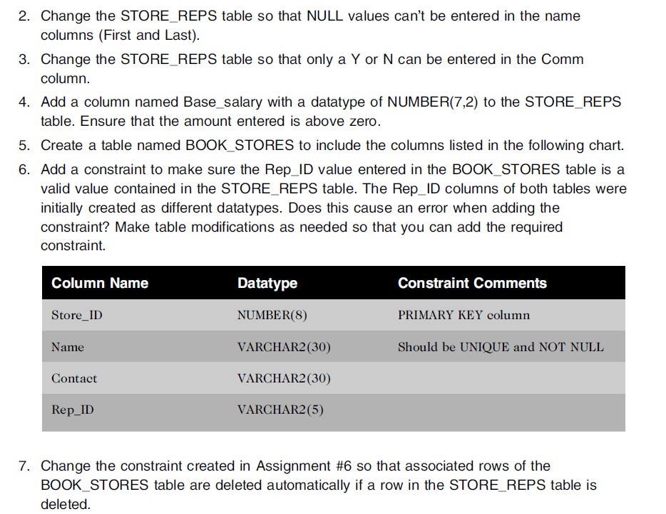
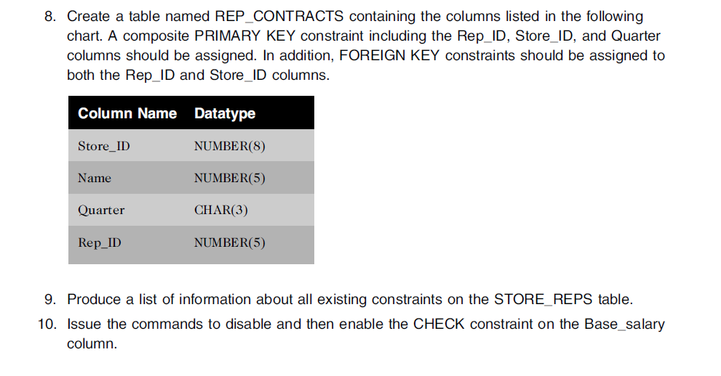

11. Create below 3 tables from ERD diagram for HR department.. Make sure using NUMBER in Oracle instead of INTEGER or DECIMAL
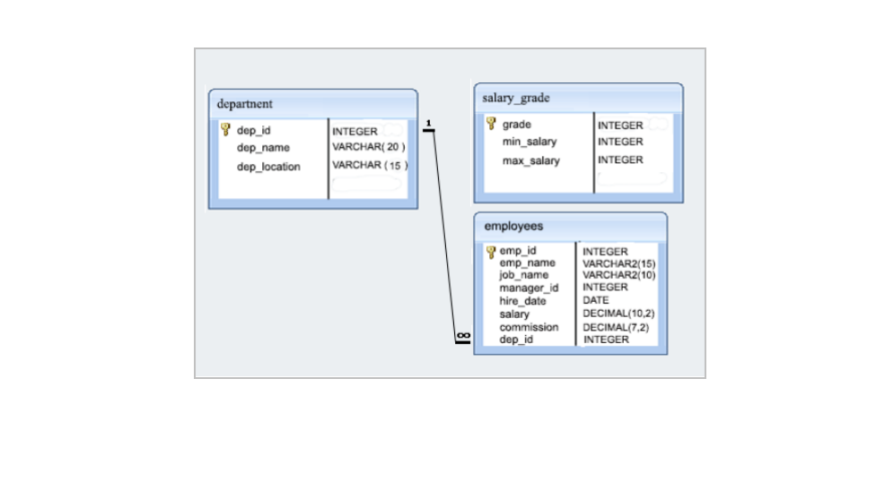

This following section (Lab C) is for practice SELECT command to query data.

Lab Section - C) SELECT queries

Develop SQL code for below questions.

1- (Please Use Dream Home Database sample Data set)

- Find sum(total) salary in each branch and total number of staff working in each branch

- Provide a report for all of employees( staff) whose salary is greater than the Dream Home company’s average salary

- For each Branch office , list the staff numbers and names of staff who manage properties and the properties that they manage
Hint: Join Staff and PropertyForRent

- Increase all assistant staff salary by %30 (UPDATE)

- For staff name called Ann Beech , write an update command to promote her as Asst Manager and increase her salary to 8900 and also move her to same branch as John White (SL21)

2- Use HumanResources Database for below questions

- Display department name, manager name, and city.

- Display country name, city, and department name.
c.
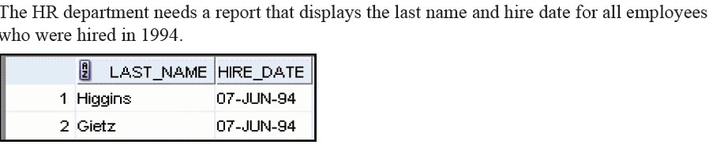
Hint : Use Like with % or TO_CHAR(Hire_Date,’YYYY’) = ‘1994’

Rubric for Lab Section A, B and C
